Chapter 11, Solution 80.

The circuit of Fig. 11.95 portrays a wattmeter connected into an ac network.
(a) Find the load current.
(b) Calculate the wattmeter reading.

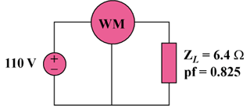

Figure 11.95
For Prob. 11.80.

Solution

